3-Tier Architecture (project)

**Name**: Mylarapu Ravi Kumar

**Batch**: 119(7am)

**Phone no**: 6302540471

**E-Mail id:** ravimylarapu39@gmail.com

1. Create one new VPC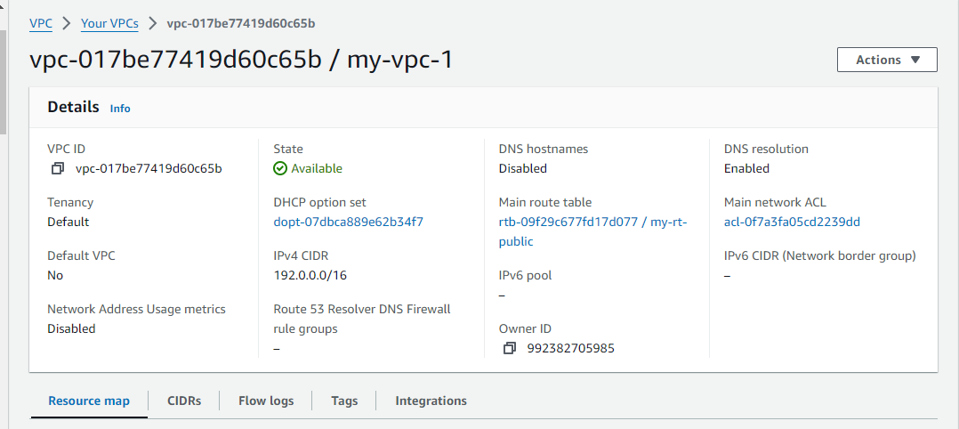
2. Create one public and two private subnets in one availability zone and also create one public and two private subnet in other availability zone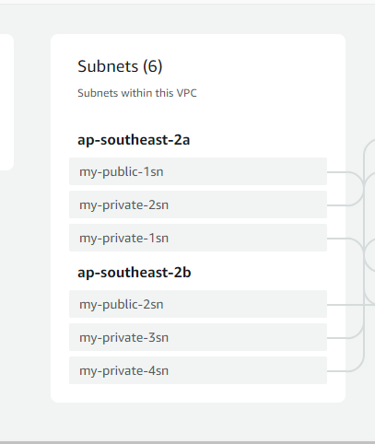
3. Next create one internet gateway and attached to VPC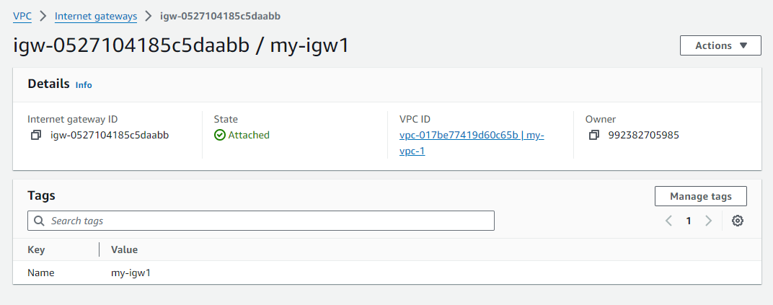
4. Next create nat gateway and attach with private subnets

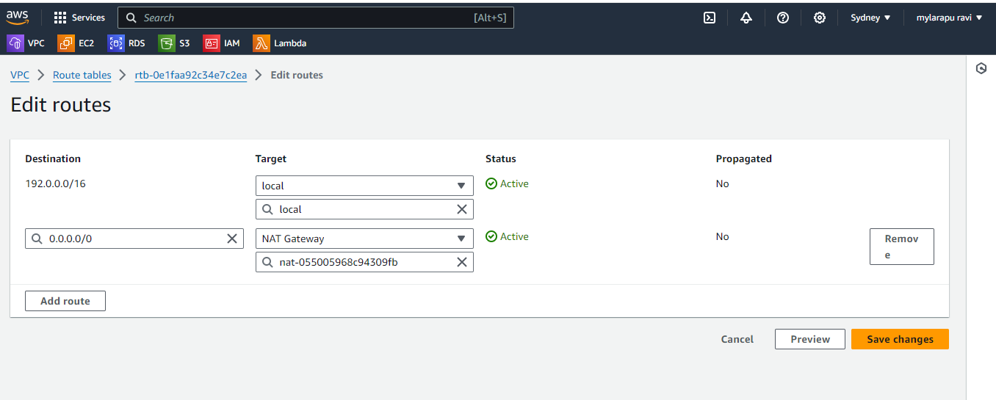

5.next go to edit subnet association and attach public subnets in public routes

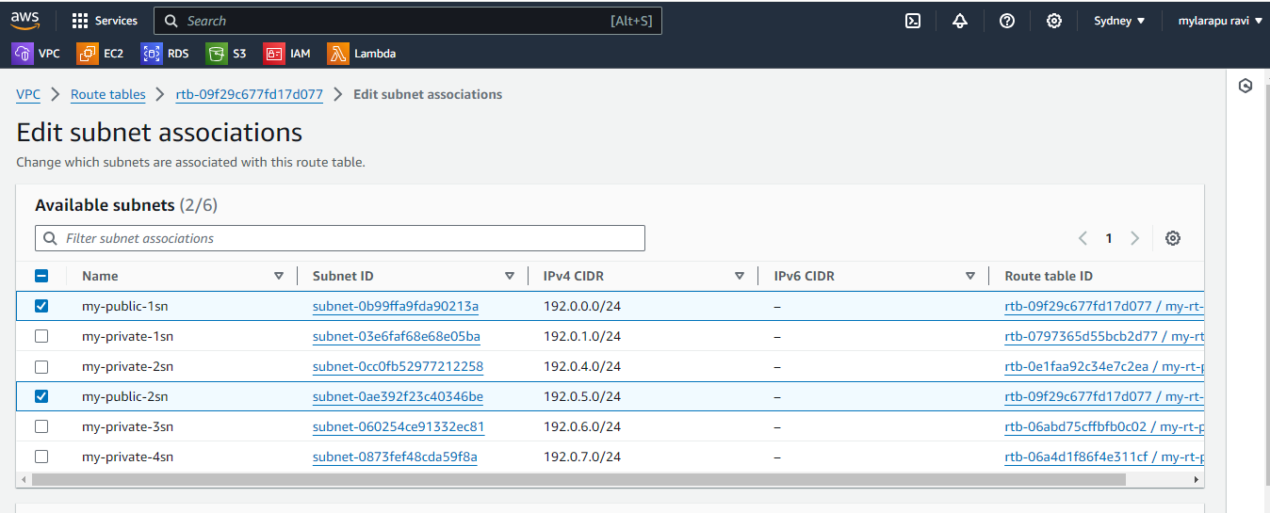

6.next go to public route table click the action button and set main route table and type set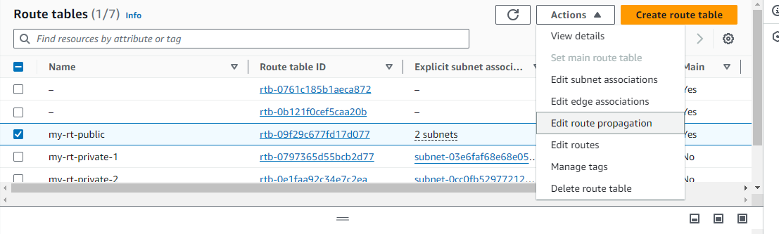

7.next go to public subnet and click and edit subnet settings and click the enable auto assign public ipv4 address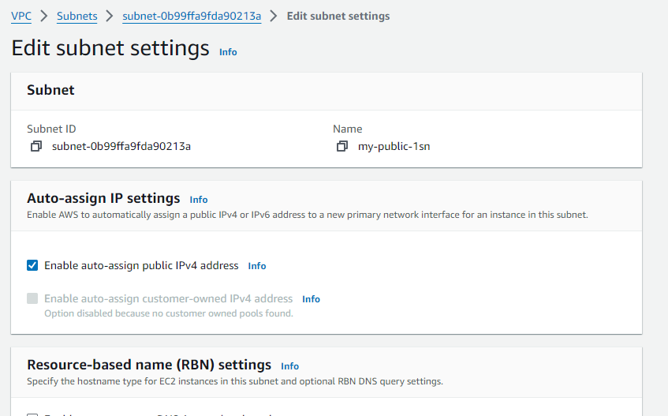

# **Web tier:**

1. Create new instance template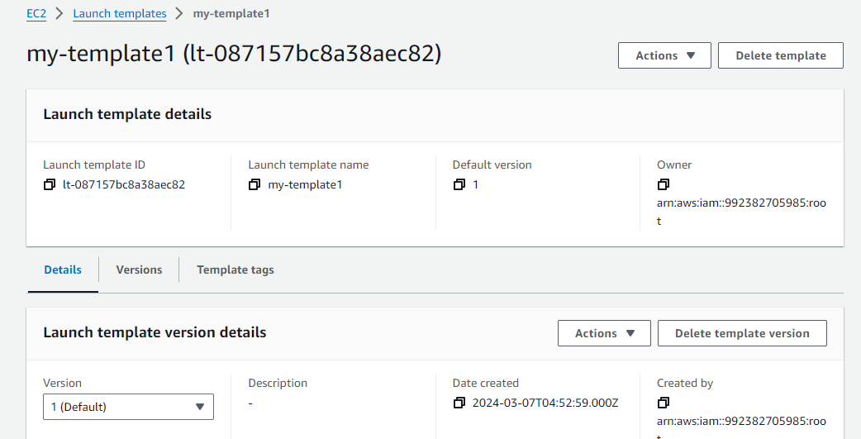
2. Next create auto scaling groups and follow the steps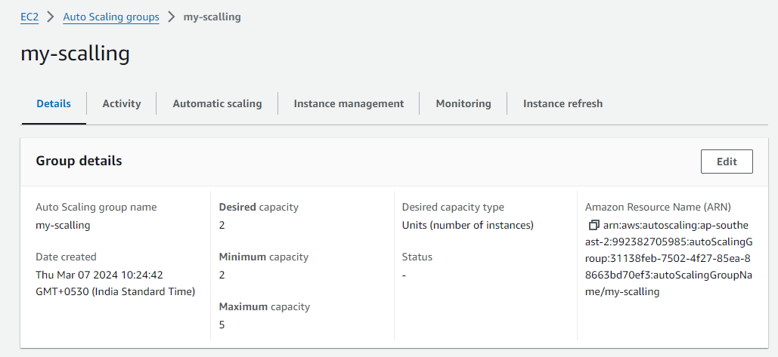
3. Next create instance security groups

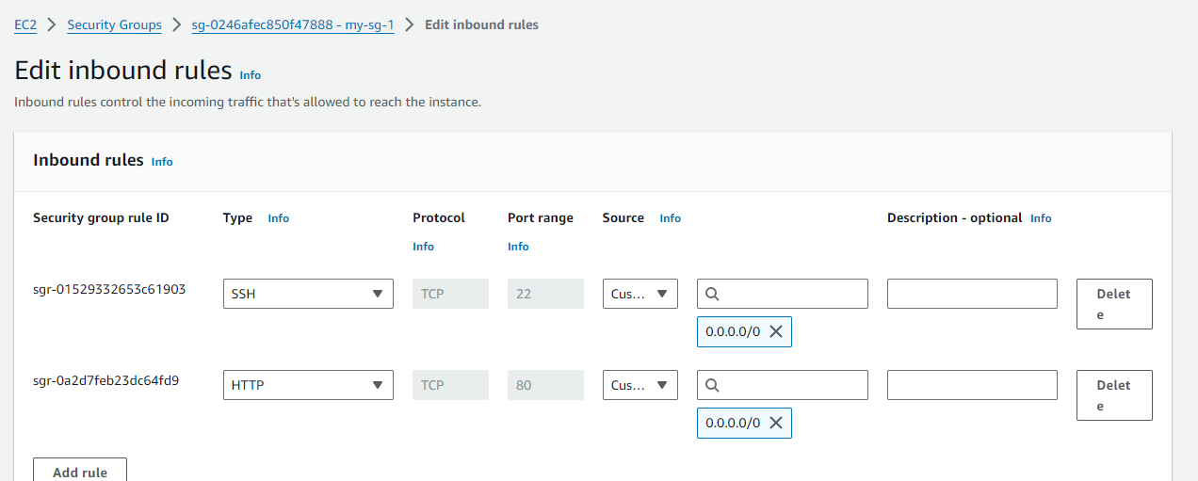

4. After creating auto scaling now create instance automatically

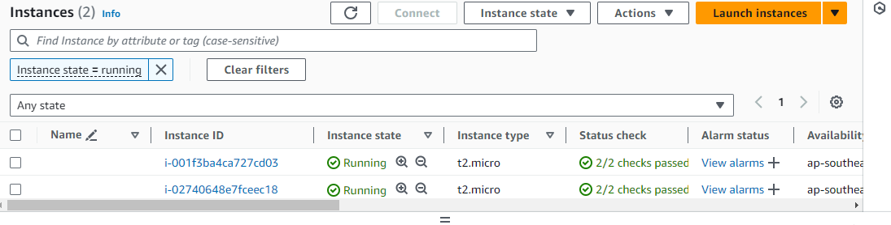

5.next connect to one instance 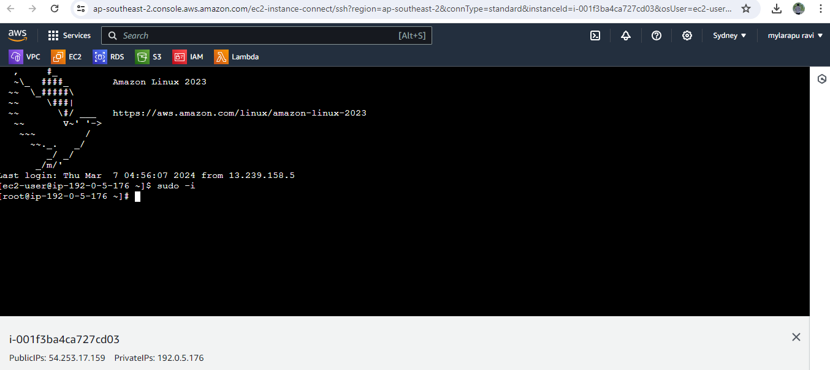

## Application tier

1.first create instance template 2 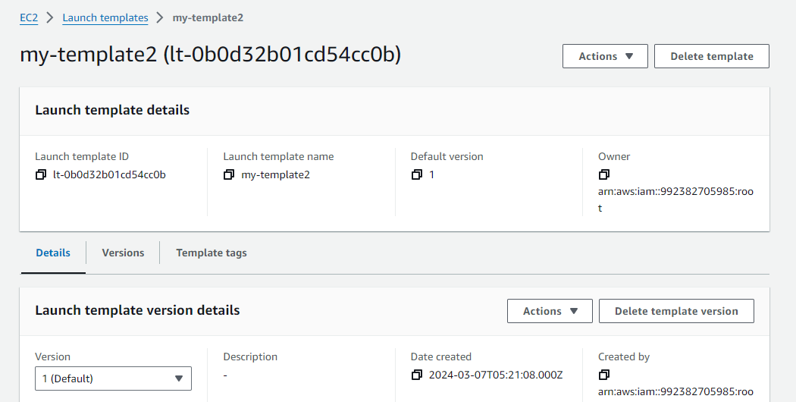

2.next create auto scaling by creating load balancer 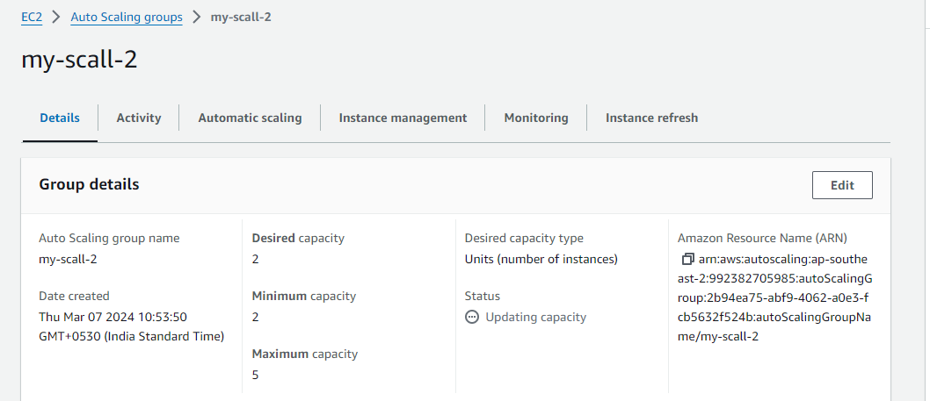

3. we can see that now we can see two new instance ( pri1, pri2)running automatically with attached private subnets 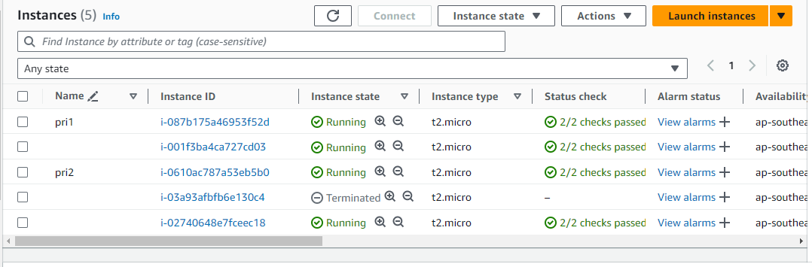

4.to connect pri 1 instance we need to connect public instance and do the following task 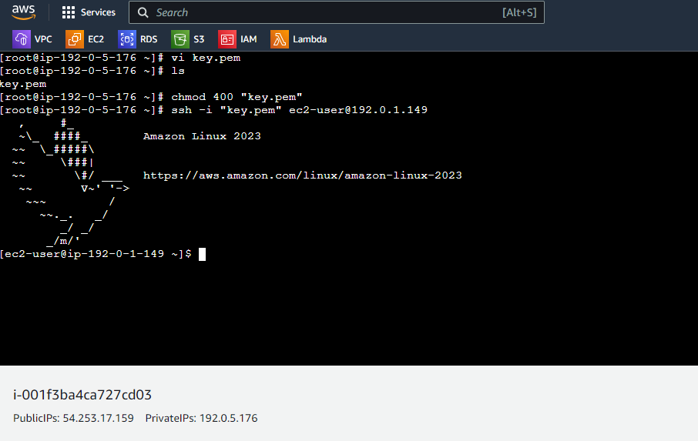

# Database tier:

1. Create security groups 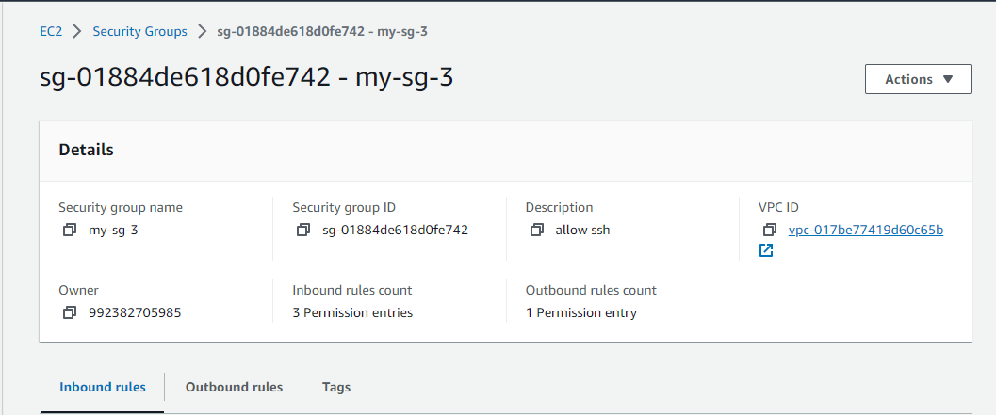
2. Next create Relational Database subnet groups

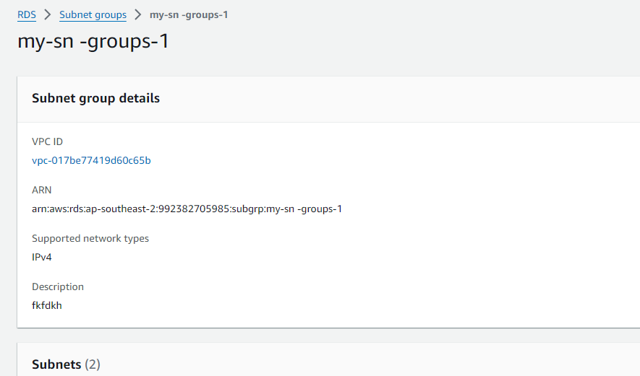

3.next create a Database following steps

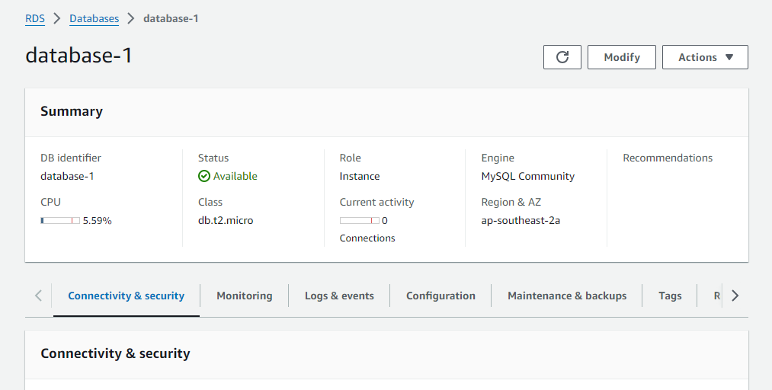

4.connect to an instance doing following steps

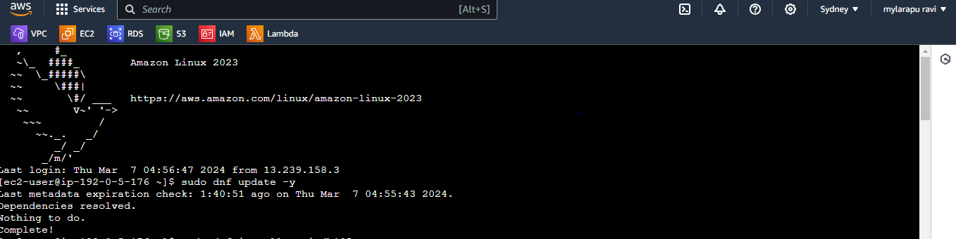

5.install MariaDB 105 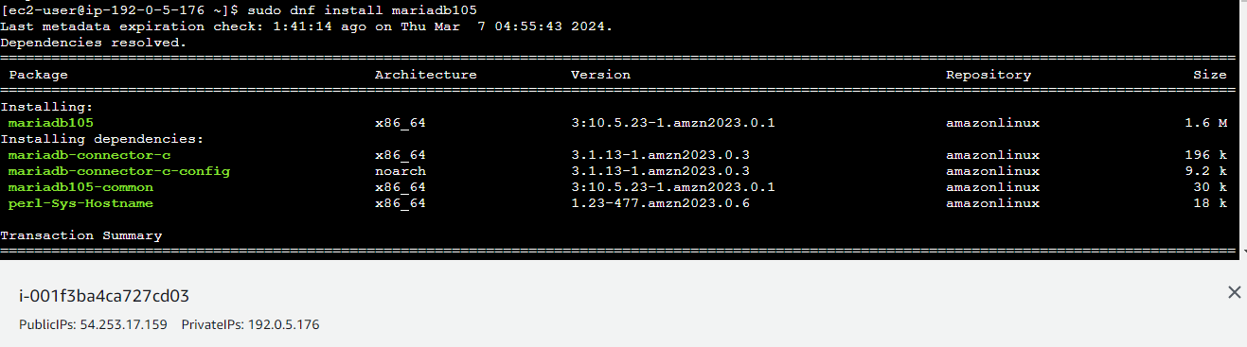

Final overview 